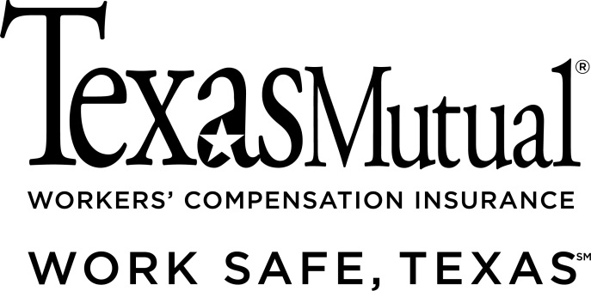

This Sample Drug Policy is provided as a service to our policyholders, and Texas Mutual Insurance Company makes no express or implied warranties or assurances through this Sample Drug Policy. The information contained within this Program may be copied for use by our policyholders in implementing suggested program elements. The materials and information provided are not intended in any way to warrant or assure that our policyholder’s premises, workplace, operations, machinery or equipment are safe or healthful or are in compliance with any law, rule, or regulation whether or not our policyholders implement or adhere to the Sample Drug Policy and the information contained therein. It is an employer’s responsibility to comply with the law and provide a safe workplace and premises and to ensure this template is modeled to your specific operations. Our policyholders are encouraged to review all applicable federal, state and local laws, rules and regulations and to seek the opinion of counsel, as appropriate, regarding compliance therewith.

A compliant policy must:

- State its purpose and scope.
- Cover alcoholic beverages, inhalants and illegal drugs. It may cover prescription drugs, as well.
- State the consequences to employees who violate the policy.
- Describe available treatment programs, if any, and how to request them.
- State the availability of and requirements for participation in drug and alcohol abuse education and treatment programs, if any.
- Describe any drug testing program implemented by the employer.

You can use the following sample drug and alcohol abuse policy to develop a policy that works for your business. We have included two optional items, shown in italics: drug testing and offer of assistance through an employee assistance program or health insurance.

Entities that receive federal grant money must also comply with additional requirements outlined in 41 U.S.C. 702. Please consult with your legal advisor regarding any drug abuse or drug testing policy adopted by you.
Sample Drug-Free Workplace Policy for Texas Employers

____________________ (company) is a drug-free workplace. The purpose of this policy is to ensure the safety of all employees and to promote productivity. This policy applies to all employees, contractors, and temporary workers. Substances covered under this policy include alcohol, illegal drugs, inhalants, prescription drugs, synthetic drugs and over-the-counter drugs.

We reserve the right to inspect company premises, including company vehicles, desks, lockers, storage areas, work areas, offices and other property supplied by the company. All such property is company property. Employees may not install private locks on any property supplied by the company. We reserve the right to conduct alcohol and drug tests at any time. We may terminate your employment if you violate this policy, refuse to be tested, provide false information, or fail to cooperate in a company investigation regarding drug or alcohol use.

Definitions under this policy

1. “Alcohol” means the intoxicating agent in beverage alcohol.

2. “Alcohol concentration” means the number of grams of alcohol per:
a. 210 liters of breath,
b. 100 milliliters of whole blood, or
c. 67 milliliters of urine.

4. “Company premises” include our buildings, grounds, parking lots, and company-provided vehicles.

5. “Controlled Substance” has the meaning assigned by 21 U.S.C. 802 and Section 481.002(5) and (6) of the Texas Health and Safety Code.

6. “Drug” means any substance (other than alcohol) that has known mind- or function-altering effects on humans, including controlled substances, structural analogs of controlled substances, illegal drugs, prescription drugs, over-the-counter drugs and inhalants.

7. “Drug-Free Workplace” means a workplace where employees are not under the influence of drugs or alcohol.

8. “Drug Metabolite” is the detectable substance in a drug.

9. “Illegal Drug” is any drug that is illegal for possession, use, sale, or transfer for those who lack the appropriate license, registration or prescription, as defined by Texas and federal law.

10. An “inhalant” is any substance that produces mind- or function-altering effects on humans when inhaled.

11. “Under the Influence” is a state of having:
a. a detectable level of the metabolite of an illegal drug, or
b. an alcohol concentration of 0.04 or more, or
c. not having the normal use of mental or physical faculties based on the introduction into the body of alcohol or drugs, or both.

Company rules

You must follow these rules while you are on company premises and while you conduct company business. These rules apply any place you conduct company business, including a company vehicle or your own vehicle:

1. You may not use, possess or be under the influence of alcohol on company premises. If management approves, you may drink moderately at certain off-premises, business-related meetings or social gatherings.

2. You may not use, possess or be under the influence of illegal drugs.

3. You may not sell, buy, transfer or distribute drugs. We reserve the right to report such actions to the authorities.

4. You may not sell, buy, transfer or distribute drug paraphernalia.

5. You may not use or be under the influence of inhalants.

6. You must follow these rules if you take prescription or over-the-counter drugs while on company premises or while conducting company business:

- You may use a prescription drug only if a licensed health care provider prescribed it to you within the last year.
- You may use prescription or over-the-counter drugs only if they do not generally affect your ability to work safely and effectively.
- You must keep these drugs in their original containers or bring only a single-day supply.

The company reserves the right to consult a doctor to determine if a prescription or over-the-counter drug may create a risk of harm to you or others if you use it on the job. The company may change your work duties or restrict you from working while you are using a prescription or over-the-counter drug that creates such a risk.

7. You may not use machinery while taking prescription or over-the-counter drugs that impair your ability to work safely. This includes vehicles.

8. You must cooperate with any investigation into drug or alcohol use. An investigation may include tests to detect the use of alcohol, drugs or inhalants.

Testing

Testing may include urine, blood, breathalyzer oral fluid or hair tests. Before testing, you will have the chance to explain the legal use of any drugs.

Assistance

Our employee assistance program provides education on drug and alcohol abuse. You can also get counseling on substance abuse and other issues. For more information, call the employee assistance program at ______________ (phone number).

Our health care insurance provides treatment for substance abuse. For more information, call _______________ (phone number).

Agreement to follow policy

I have received and read a copy of the __________________Drug-Free Workplace Policy. I agree to follow the rules in the policy.

I consent to a drug or alcohol test as a condition of my initial employment or continued employment. I authorize any laboratory or medical provider to release such test results to the company.

I release the company, its officers, directors, agents, employees, assigns and successors and all other persons or firms associated with or in any manner connected with the company, from any and all liability or claims that may arise out of, or in connection with a drug or alcohol test or this policy, for requiring tests, and any adverse employment action taken as a result of tests or test results. I understand that I am still an at-will employee and that this statement does not limit my or the company's right to terminate my employment at any time for any reason.

_____________________________________ _________________
Employee Signature Date

_____________________
Name (Please Print)

__________________________________ _________________
Witness Signature Date

_____________________________________
Witness Name (Please Print)

Related document

For a copy of USCIS Form I-9, Employment Eligibility Verification, visit the U.S. Citizenship and Immigration Services at http://www.uscis.gov/sites/default/files/files/form/i-9.pdf

